Module 8) Bootstrap Basic & Advanced

1. **What are the advantages of Bootstrap?**

**ANS :**

* Access to a Vast Open Source Community of Resources. There is a vast community of open-source developers who contribute regularly to Bootstrap.
* Consistent Designs.
* Access to Support.
* Fast Development.
* **Responsive Features** : Bootstrap responsive CSS adjusts to phone, tablets, and desktops.
* **Easy to use** : Anybody with just basic knowledge of HTML and CSS can start using Bootstrap
* **Mobile-first-approach** : in Bootstrap 3, mobile -first style are part of the core framework
* **Browser compatibility** : Bootstrap is compatible with all modern browsers ( Chrome, Firefox, Internet Explorer, Edge, Safari , and Opera).
* **Integration with JavaScript:** Bootstrap comes with pre-built JavaScript plugins (e.g., carousels, tooltips, modals), saving time and effort in implementing interactive features.
* **Time – efficient :** its ready to use componets and responsive desing features speed up the development process significantly.
* **Customizable:** While it provides default styles, Bootstrap is highly customizable. You can modify its components, styles, and behaviors to suit specific project needs.

1. **What is a Bootstrap Container, and how does it work?**

**ANS :**

In Bootstrap, a container is a fundamental layout element used to create a consistent and responsive design. It is a wrapper that helps to structure the content within a web page. There are primarily three types of containers in Bootstrap:

1. **Container:** This is the standard container class in Bootstrap. It provides a responsive fixed width container, meaning the width adjusts according to the screen size but has predefined maximum widths for different breakpoints (like small, medium, large, etc.). It ensures that content doesn't stretch too wide on larger screens and doesn't become too cramped on smaller ones.

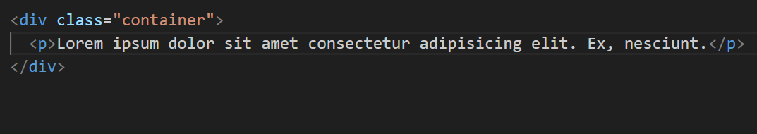

1. **Container-fluid:** This container class spans the entire width of the viewport across all devices. It adjusts fluidly to the width of the screen, without any fixed maximum widths for different breakpoints.

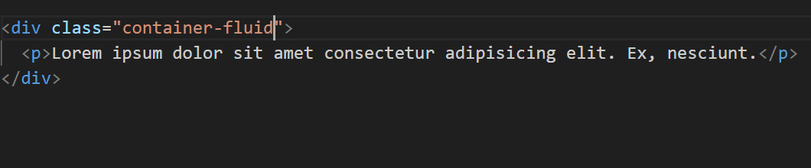

1. **Container-{breakpoint}:** Bootstrap also provides responsive containers specific to breakpoints, like **.container-sm**, **.container-md**, **.container-lg**, etc. These allow developers to have more control over the container's width at different screen sizes.

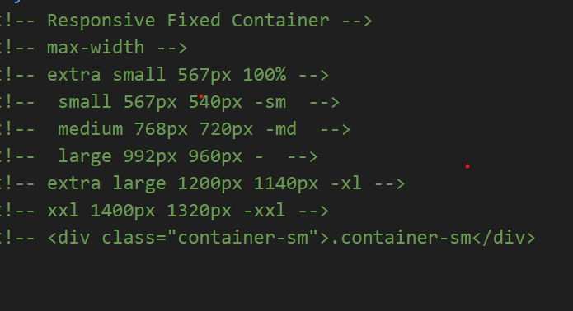

Containers work by setting the maximum width of the content within them and centering that content on the page. They help in creating a structured layout for your web content while ensuring responsiveness across various devices.

1. **What are the default Bootstrap text settings?**

**ANS :**

Bootstrap has default text settings that define the font styles, sizes, and colors for various text elements. Here are some of the default text settings in Bootstrap:

1. **Font family:** Bootstrap uses the system's default font family, typically sans-serif.
2. **Font sizes:**
   * font-size-base: The base font size is set to 16px.
   * Text sizes are adjusted using relative units (rem) to maintain scalability.
3. **Font weights:**
   * font-weight-normal: Normal font weight (400).
   * font-weight-bold: Bold font weight (700).
4. **Line heights:**
   * line-height-base: Set to 1.5.
5. **Text colors:**
   * text-muted: Light gray for muted text.
   * text-primary, text-secondary, text-success, text-danger, text-warning, text-info, text-light, text-dark: Various predefined text colors for different contextual uses.

Bootstrap's utility classes allow for easy modification and customization of text elements. Classes like .text-center, .text-right, .text-uppercase, .text-lowercase, and .text-capitalize help align or modify text appearance.

For more precise adjustments, Bootstrap also provides typography utility classes such as .font-weight-bold, .font-italic, .text-primary, etc., enabling developers to apply specific font styles or colors.

Keep in mind that these defaults can be customized or overridden by defining your own CSS styles or by utilizing Bootstrap's utility classes and theming options.

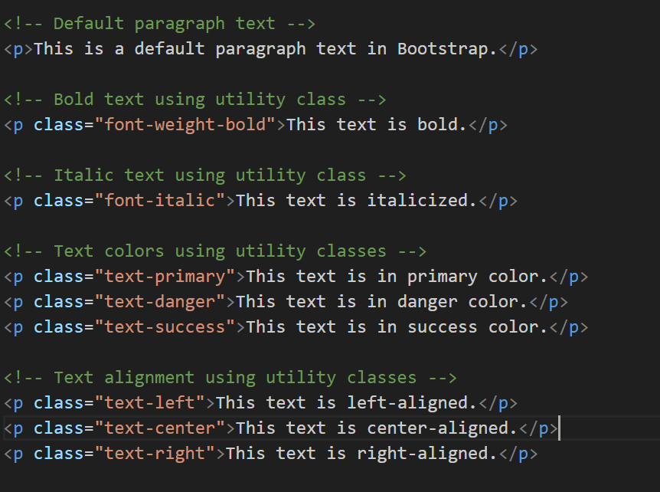

1. **What do you know about the Bootstrap Grid System?**

**ANS :**

The Bootstrap Grid System is a powerful, responsive, mobile-first grid system used for building layouts of all shapes and sizes within a web page. It's a fundamental part of Bootstrap, allowing developers to create complex responsive layouts with ease. Here are key aspects:

**1. Grid Structure:**

* **Rows and Columns:** The grid system is based on a 12-column layout. Rows are horizontal containers for columns.
* **Column Sizing:** Columns can be combined and sized in proportions adding up to 12 columns per row.
* **Responsive Behavior:** Grid classes can be tailored for different device sizes (extra small, small, medium, large, extra large) using breakpoint-specific classes.

2**. Responsive Design:**

* **Mobile-First Approach**: Bootstrap employs a mobile-first approach, ensuring that designs start from a mobile view and then scale up for larger devices.
* **Breakpoints:** Classes like .col-, .col-sm-, .col-md-, .col-lg-, and .col-xl- define the column behavior for different screen sizes.

**3. Grid Components:**

* **Containers:** .container creates a responsive fixed-width container.
* **Fluid Containers:** .container-fluid creates a full-width container spanning the entire viewport.
* **Nested Grids:** Grids can be nested within one another for more complex layouts.

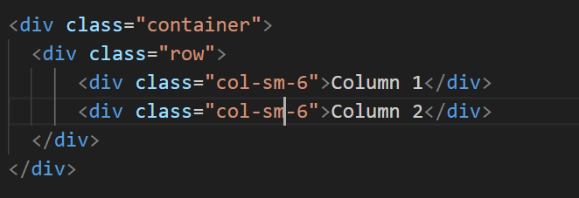

* **.container** creates a responsive fixed-width container.
* **.row** creates a horizontal row to hold columns.
* **.col-md-6** specifies that each column will take up half the width on medium-sized screens and above.

**Advantages:**

* + Responsive Layouts: Easily create responsive designs for various device sizes.
  + Consistency: Ensures consistent spacing and alignment across different devices.
  + Flexibility: Allows for easy rearrangement of content based on screen sizes.
  + Compatibility: Bootstrap's grid system integrates seamlessly with other Bootstrap components and utilities.

1. **What is the difference between Bootstrap 4 and Bootstrap 5**

**ANS :**

Bootstrap 4 and Bootstrap 5 are both popular front-end frameworks, but Bootstrap 5 introduced several changes and enhancements over its predecessor. Here are some key differences between the two versions:

**1. jQuery Dependency:**

* **Bootstrap 4:** Depended on jQuery for some of its functionality.
* **Bootstrap 5:** Eliminated the dependency on jQuery, opting for a pure JavaScript approach, resulting in a lighter and more efficient codebase.

**2. Improved Utility Classes:**

* **Bootstrap 5:** Expanded utility classes for spacing, typography, and layout, providing more flexibility and customization options without the need for additional CSS.

**3. Customization and Theming:**

* **Bootstrap 4:** Customization and theming options were available but were somewhat limited.
* **Bootstrap 5:** Introduced a more robust theming system, allowing easier customization through SASS variables, enabling developers to create unique designs more easily.

**4. Dropped Legacy Browser Support:**

* **Bootstrap 5:** Focused on modern browser support, dropping support for Internet Explorer (IE) entirely to streamline development and utilize modern CSS features without worrying about legacy browser compatibility.

**5. New Components and Features:**

* **Bootstrap 5:** Introduces new components such as off-canvas sidebar, improved form components, updated accordion, switch, and more, along with enhancements to existing components.

**6. Grid System Enhancement:**

* **Bootstrap 5:** The grid system received updates like improved gutter classes, horizontal and vertical gutters, and a more flexible and cleaner grid structure.

**7. File Structure and Size:**

* **Bootstrap 5:** Streamlined file structure, removed redundant or unused CSS classes, resulting in a smaller overall file size compared to Bootstrap 4.

**8. Documentation and Accessibility:**

* **Bootstrap 5:** Enhanced documentation and improved accessibility features to ensure better usability and understanding of the framework.
* **Considerations:**

While Bootstrap 5 brings significant improvements, migrating from Bootstrap 4 to Bootstrap 5 might require adjustments due to changes in class names, behavior, and syntax.

Bootstrap 5's drop of jQuery support might affect projects heavily relying on jQuery-based functionalities in Bootstrap 4.

Understanding these differences helps developers choose the version that best aligns with their project requirements, considering factors such as performance, modern browser support, customization options, and ease of migration from previous versions

1. **What is a Button Group, and what is the class for a basic Button Group?**

**ANS :**

A Button Group in Bootstrap is a set of buttons grouped together, allowing users to select one option from a set of choices or perform related actions. These groups can visually organize buttons to indicate their relationship or purpose.

The class used for a basic Button Group in Bootstrap is .btn-group.

**Example of a Basic Button Group:**

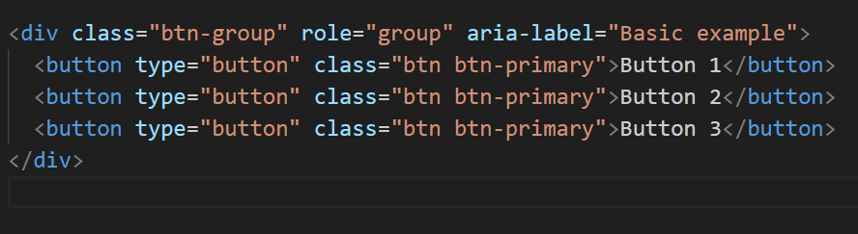

**Explanation:**

The <div> with the class .btn-group wraps the buttons together.

role="group" and aria-label attributes are used for accessibility, indicating that these buttons form a group and providing a label for screen readers.

**Types of Button Groups:**

**Basic Button Group:** A group of buttons placed together.

**Button Toolbar:** Combines multiple button groups into one cohesive component.

**Sizing:** Button groups can be resized using .btn-group-lg, .btn-group-sm, or .btn-group-xs classes.

**Vertical Button Group:** Vertical arrangement of buttons using .btn-group-vertical.

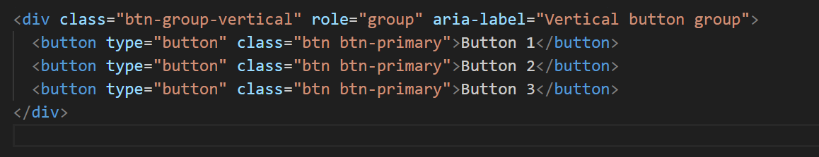

Button groups in Bootstrap allow for a cleaner and more organized presentation of buttons, especially when they are related or serve similar purposes within a UI. They aid in providing clear choices or actions to users.

**Toggle Behavior:**

Using JavaScript, buttons within a group can be made to toggle (like radio buttons) using the **data-bs-toggle="button"** attribute and the **.btn-group-toggle** class.

These variations in Bootstrap Button Groups offer versatile ways to structure and style sets of buttons, enabling developers to create intuitive and well-organized interfaces for users to interact with.

1. **How can you use Bootstrap to make thumbnails?**

**ANS :**  
Bootstrap provides a simple and effective way to create thumbnails, allowing you to display images or content in a grid-like layout. The **.img-thumbnail** class in Bootstrap helps create visually appealing bordered thumbnails for images or other elements.

**Basic Image Thumbnails:**

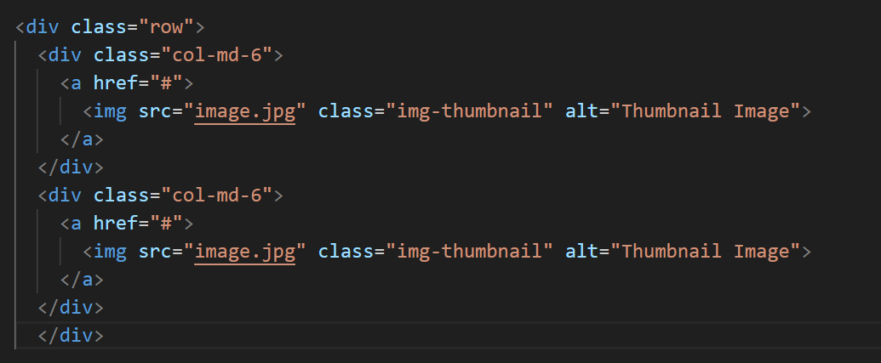

**Custom Content Thumbnails:**

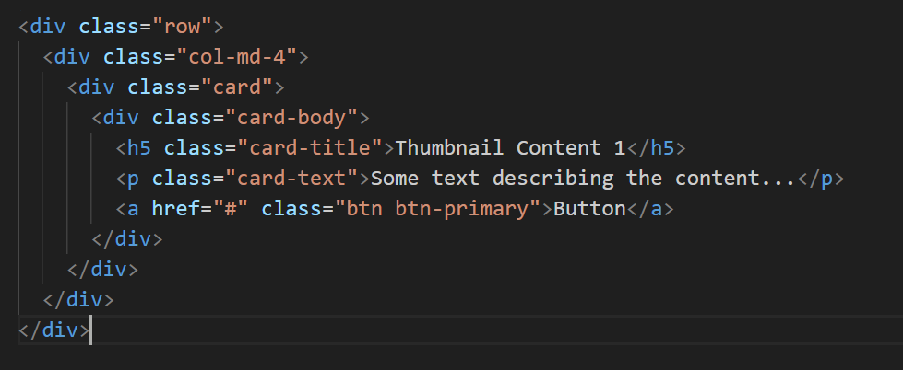

**Explanation:**

* **Image Thumbnails:** The **.img-thumbnail** class creates bordered image thumbnails within a grid layout using Bootstrap's grid system.
* **Custom Content Thumbnails:** You can wrap your custom content (text, buttons, etc.) inside Bootstrap's card component to create custom thumbnails.

Customizing thumbnail appearance is easy with Bootstrap's utility classes and components. You can adjust the size, borders, and overall style of thumbnails to suit your design needs.

1. **In Bootstrap 4, what is flexbox?**

**ANS :**

In Bootstrap 4, Flexbox refers to the flexible box layout module of CSS that Bootstrap utilizes extensively for its grid system, layout, and alignment of elements. Flexbox is a powerful layout model that allows the creation of complex and responsive designs with a simpler and more predictable structure.

Flexbox. The biggest difference between Bootstrap 3 and Bootstrap 4 is that Bootstrap 4 now uses flexbox, instead of floats, to handle the layout. The Flexible Box Layout Module, makes it easier to design flexible responsive layout structure without using float or positioning.

1. **Flexible Box Model:**
   * Flexbox provides a one-dimensional layout method for laying out items in rows or columns.
   * Bootstrap's grid system heavily relies on Flexbox to create responsive and flexible layouts.
2. **Container and Items:**
   * Flexbox works with two main components: the flex container and flex items.
   * In Bootstrap 4, the grid system's rows (**<div class="row">**) act as flex containers, and the columns (**<div class="col-">**) are flex items.
3. **Alignment and Distribution:**
   * Flexbox simplifies alignment and distribution of elements both horizontally and vertically within flex containers.
   * Bootstrap's Flexbox utilities like **.justify-content-\***, **.align-items-\***, and **.align-self-\*** assist in aligning content and adjusting spacing.
4. **Responsive Design:**
   * Flexbox makes it easier to create responsive designs by allowing elements to adjust their size and layout based on available space.
   * Bootstrap's responsive classes combined with Flexbox allow for consistent and adaptive layouts across various screen sizes.
5. **Ordering Elements:**
   * Flexbox enables reordering of elements without changing the HTML structure using the **.order-\*** utility classes.
6. **Flexible Sizing:**
   * Flexbox allows flexible sizing of elements, enabling them to grow or shrink based on available space or predefined proportions.

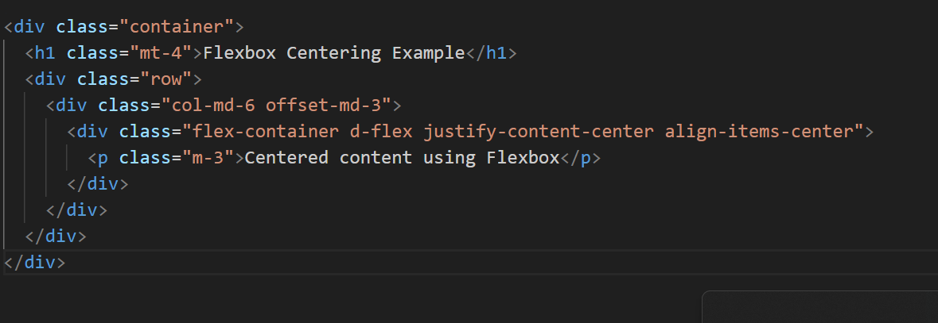

**Explanation:**

* A **<div>** with the class **.flex-container** is created within a Bootstrap column (**col-md-6**) to demonstrate Flexbox alignment.
* The **.d-flex** class makes the container a flex container.
* **justify-content-center** and **align-items-center** classes are used to horizontally and vertically center the content within the flex container.

This example showcases how Flexbox, in conjunction with Bootstrap 4 classes, allows you to create responsive and centered layouts easily by leveraging the flexbox properties for alignment and distribution of content within containers.

1. **How can one create an alert in Bootstrap?**

**ANS :** In Bootstrap, you can create alerts using predefined classes to emphasize or notify users about certain information. Here's a basic example:

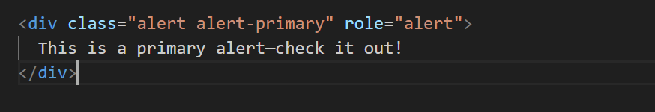

Bootstrap provides various contextual classes for alerts (**alert-primary**, **alert-secondary**, **alert-success**, **alert-danger**, **alert-warning**, **alert-info**, **alert-light**, **alert-dark**) which you can use to denote different types of messages.

To create a dismissible alert (one that users can close), add the **alert-dismissible** class and a close button:

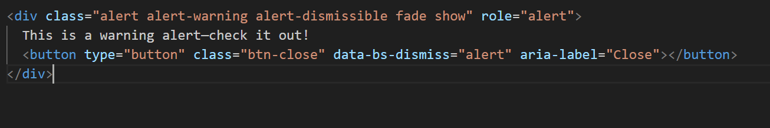

Make sure you include the necessary Bootstrap CSS and JavaScript files in your project for these alerts to work properly. The JavaScript is specifically needed for the dismiss functionality (**data-bs-dismiss="alert"**).

Remember, Bootstrap provides flexibility in styling alerts, and you can further customize them by adding your CSS or JavaScript to meet specific design or functionality requirements.

1. **What is a bootstrap card and how would you create one?**

**ANS :** Bootstrap cards are flexible and extensible content containers. They allow you to display various types of content, such as text, images, links, and more, within a structured layout. Creating a Bootstrap card involves using predefined HTML structure and classes. Here's an example of creating a simple Bootstrap card:

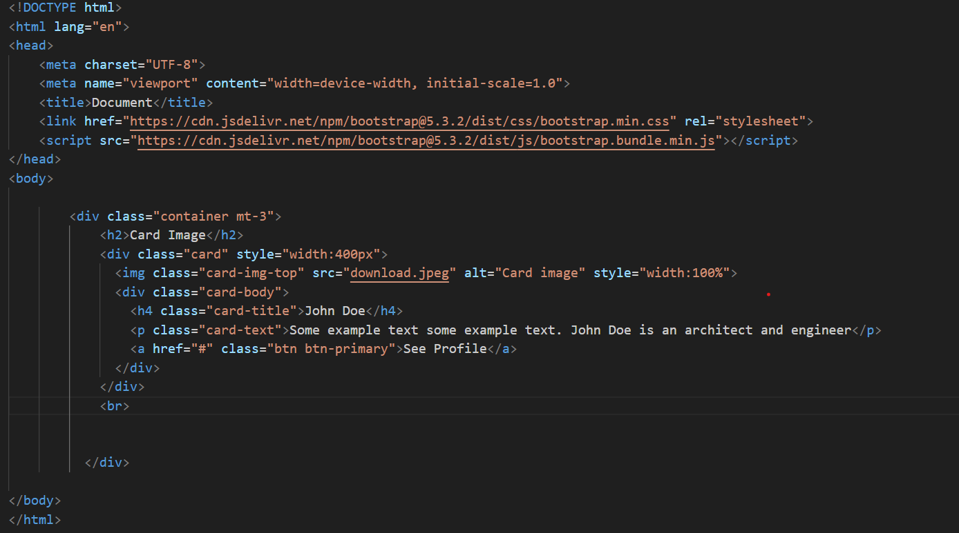

This basic structure demonstrates the main components of a card:

* <div class="card">: This is the main container for the card.
* <img src="..." class="card-img-top" alt="Card Image">: An optional img element at the top of the card, serving as the card's header or main image.
* <div class="card-body">: This is the container for the card's content.
* <h5 class="card-title">: The title of the card.
* <p class="card-text">: The main text content of the card.
* <a href="#" class="btn btn-primary">: An example button at the bottom of the card.

Bootstrap provides various classes to customize cards further, such as card-header, card-footer, card-subtitle, card-group, card-columns, and more. These classes help in structuring and styling cards based on your design requirements.